Name:________________________________________ Date:__________
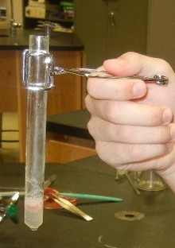

Enzyme Lab
INTRODUCTION: What would happen to your cells if they made a poisonous chemical? You might think that they would die. In fact, your cells are always making poisonous chemicals. They do not die because your cells use enzymes to break down these poisonous chemicals into harmless substances. Enzymes are proteins that speed up the rate of reactions that would otherwise happen more slowly. The enzyme is not altered by the reaction. You have hundreds of different enzymes in each of your cells.
Each of these enzymes is responsible for one particular reaction that occurs in the cell. In this lab, you will study an enzyme that is found in the cells of many living tissues. The name of the enzyme is catalase (KAT-uh-LAYSS); it speeds up a reaction which breaks down hydrogen peroxide, a toxic chemical, into 2 harmless substances--water and oxygen.

The reaction is: 2 H₂O₂ ----> 2 H₂O + O₂
This reaction is important to cells because hydrogen peroxide (H2O2) is produced as a byproduct of many normal cellular reactions. If the cells did not break down the hydrogen peroxide, they would be poisoned and die. In this lab, you will study the catalase found in potato cells. The enzyme is also found in animal livers (which we won’t use because it’s super messy). Even when a cell dies, the enzymes remain intact and active for several weeks, as long as the tissue is kept refrigerated.

PART A - Observe Normal Catalase Reaction
1. Pour a small amount of the 3% hydrogen peroxide solution into a clean cup.
2. Add a small piece of potato to the cup. Push it into the hydrogen peroxide with a stirring rod or spoon. Observe the bubbles.
What gas is being released? (consider the equation) ___________________
Throughout this investigation you will estimate the rate of the reaction (how rapidly the solution bubbles) on a scale of 0-5
(0=no reaction, 1=slow, ..... 5= very fast). Assume that the reaction in step 2 proceeded at a rate of "4"
Recall that a reaction that absorbs heat is endothermic; a reaction that gives off heat is exothermic. Now, feel the temperature of the cup with your hand.
Has it gotten warmer or colder ___________ Is the reaction endothermic or exothermic? ____________________
3. Pour off the liquid into a second cup. Assume the reaction is complete. What is this liquid composed of? _______________
What do you think would happen if you added more potato to this liquid? __________________________________
Test this and record the reaction rate. Reaction Rate ___________ (1 – 5)
4. Add another small amount of hydrogen peroxide to the potato remaining in the first cup. What is the reaction rate? ________
Is catalase reusable? Explain how you know.

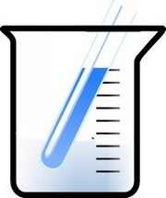
PART B - What is the Effect of Temperature on Catalase Activity?
1. Put a piece of potato into the bottom of a clean cup and cover it with a small amount of HOT water.
Let it sit for a few minutes before pouring out the water. Now add a small amount of hydrogen peroxide.
What is the reaction rate for the boiled potato and hydrogen peroxide? __________

1. Describe the relationship between catalase and hydrogen peroxide. Indicate which is the enzyme, which is the substrate and what occurs during the reaction. It may be helpful to write the equation.

2. Is catalase reusable? Use your data to support your answer.

3. How does temperature affect the reaction rate of catalase?

4. In 2-3 sentences, summarize the data and information displayed in this graph.
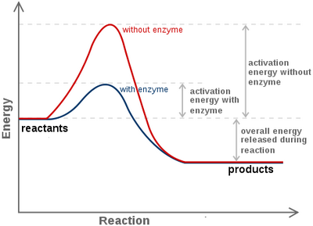
Adapted from Biologycorner.com

