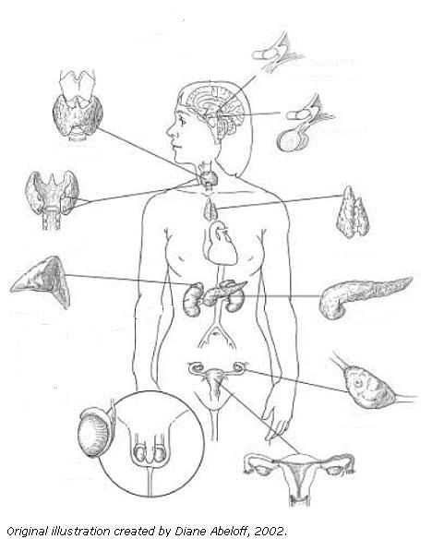Name: Key

Parathyroid Glands

Thyroid Gland

Testes

Ovaries

Pancreas

Adrenal Glands

Thymus Gland

Pituitary Glands

Hypothalamus

**Name**: