Sweat Gland Distribution Lab

Sweat is produced in exocrine glands that are found in the skin throughout the body. Each area of the body has a different distribution of sweat glands. The focus of this lab will be to compare the amount of sweat glands in two areas by using bond paper, which contains starch.

Materials
- Lugol’s iodine.
- Two 1cm x 1cm square pieces of bond paper.
- Tape.
- Paper towel.
- Two cotton swabs.

Procedure
- Place the tip of the cotton swab into the bottle of Lugol’s iodine. Place enough on the anterior surface of your forearm to cover a 1cm² area.
- Allow the iodine to dry. Take a piece of paper towel and dab the area to remove any excess.
- Place the square piece of bond paper over the area stained in iodine.
- Tape the bond paper tightly over the area.
- Repeat steps #1-4 for an area on the palm of your hand.
- Exercise for 2-3 minutes. Wait an additional 5-10 minutes.
- Remove the paper. Small, dark-colored dots indicate the location of sweat glands.
- Count the number of sweat glands and record in your data table.

Data
Location | Number of Sweat Glands (Individual)
Anterior Forearm
Palm of Hand

Create a scatterplot graph based on the measurements taken by everyone in the class. Label the y-axis as number of sweat glands. Mark data taken from the forearm as an “O” and data from the foot as an “X”.

Analysis
- Which area of the body had the greatest concentration of sweat glands?

- What is another area of the body you could test that you would expect to have a high concentration of sweat glands? A low concentration of sweat glands?

- What is the purpose of sweat?

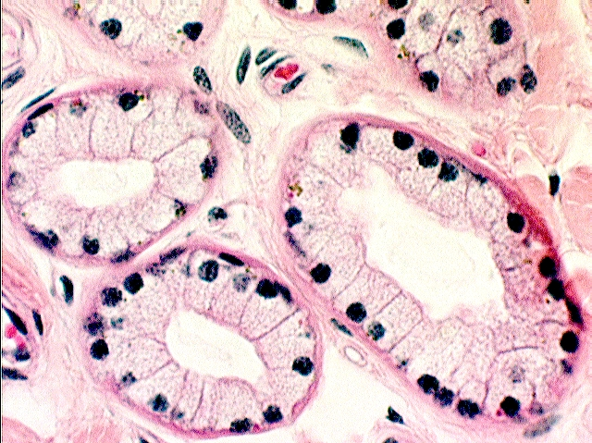
- This is a microscope slide of a cross section of three sweat glands. Label the clear, inner area called the lumen. This is where the sweat accumulates before it reaches the surface. What type of tissue is surrounding the lumen? Why would this type of tissue be present?

